QBO Post Secondary Workbook: Answer Key
Section 1 Answer Key - Setting Up a Company 2
Question 1-13: 2
Section 2 Answer Key – Accounts Receivable 8
Questions 14 – 21 8
Section 3 Answer Key – Accounts Payable 13
Questions 22 - 26 13
Section 4 Answer Key – Automating in QBO 16
Questions 27 – 28 16
Section 5 Answer Key – Company Administration 17
Question 29 17
Section 6 Answer Key – Advanced Learning 18
Questions 30 - 32 18
Section 7 Answer Key – Reporting 22
Questions 33 - 37 22

Section 1 Answer Key - Setting Up a Company
This first section will require a few different places to be reviewed in order to ensure that the company setup is correct.

Question 1-13:
Once your student has completed section 1, they will have invited you into their database to review. You would have received an email invitation that you would have had to accept. Once the invitations have all been accepted, and you are logged in as the accountant you should see a listing of all of your students when you login to your QBOA account.

Below is a screen shot of what you should be able to see:

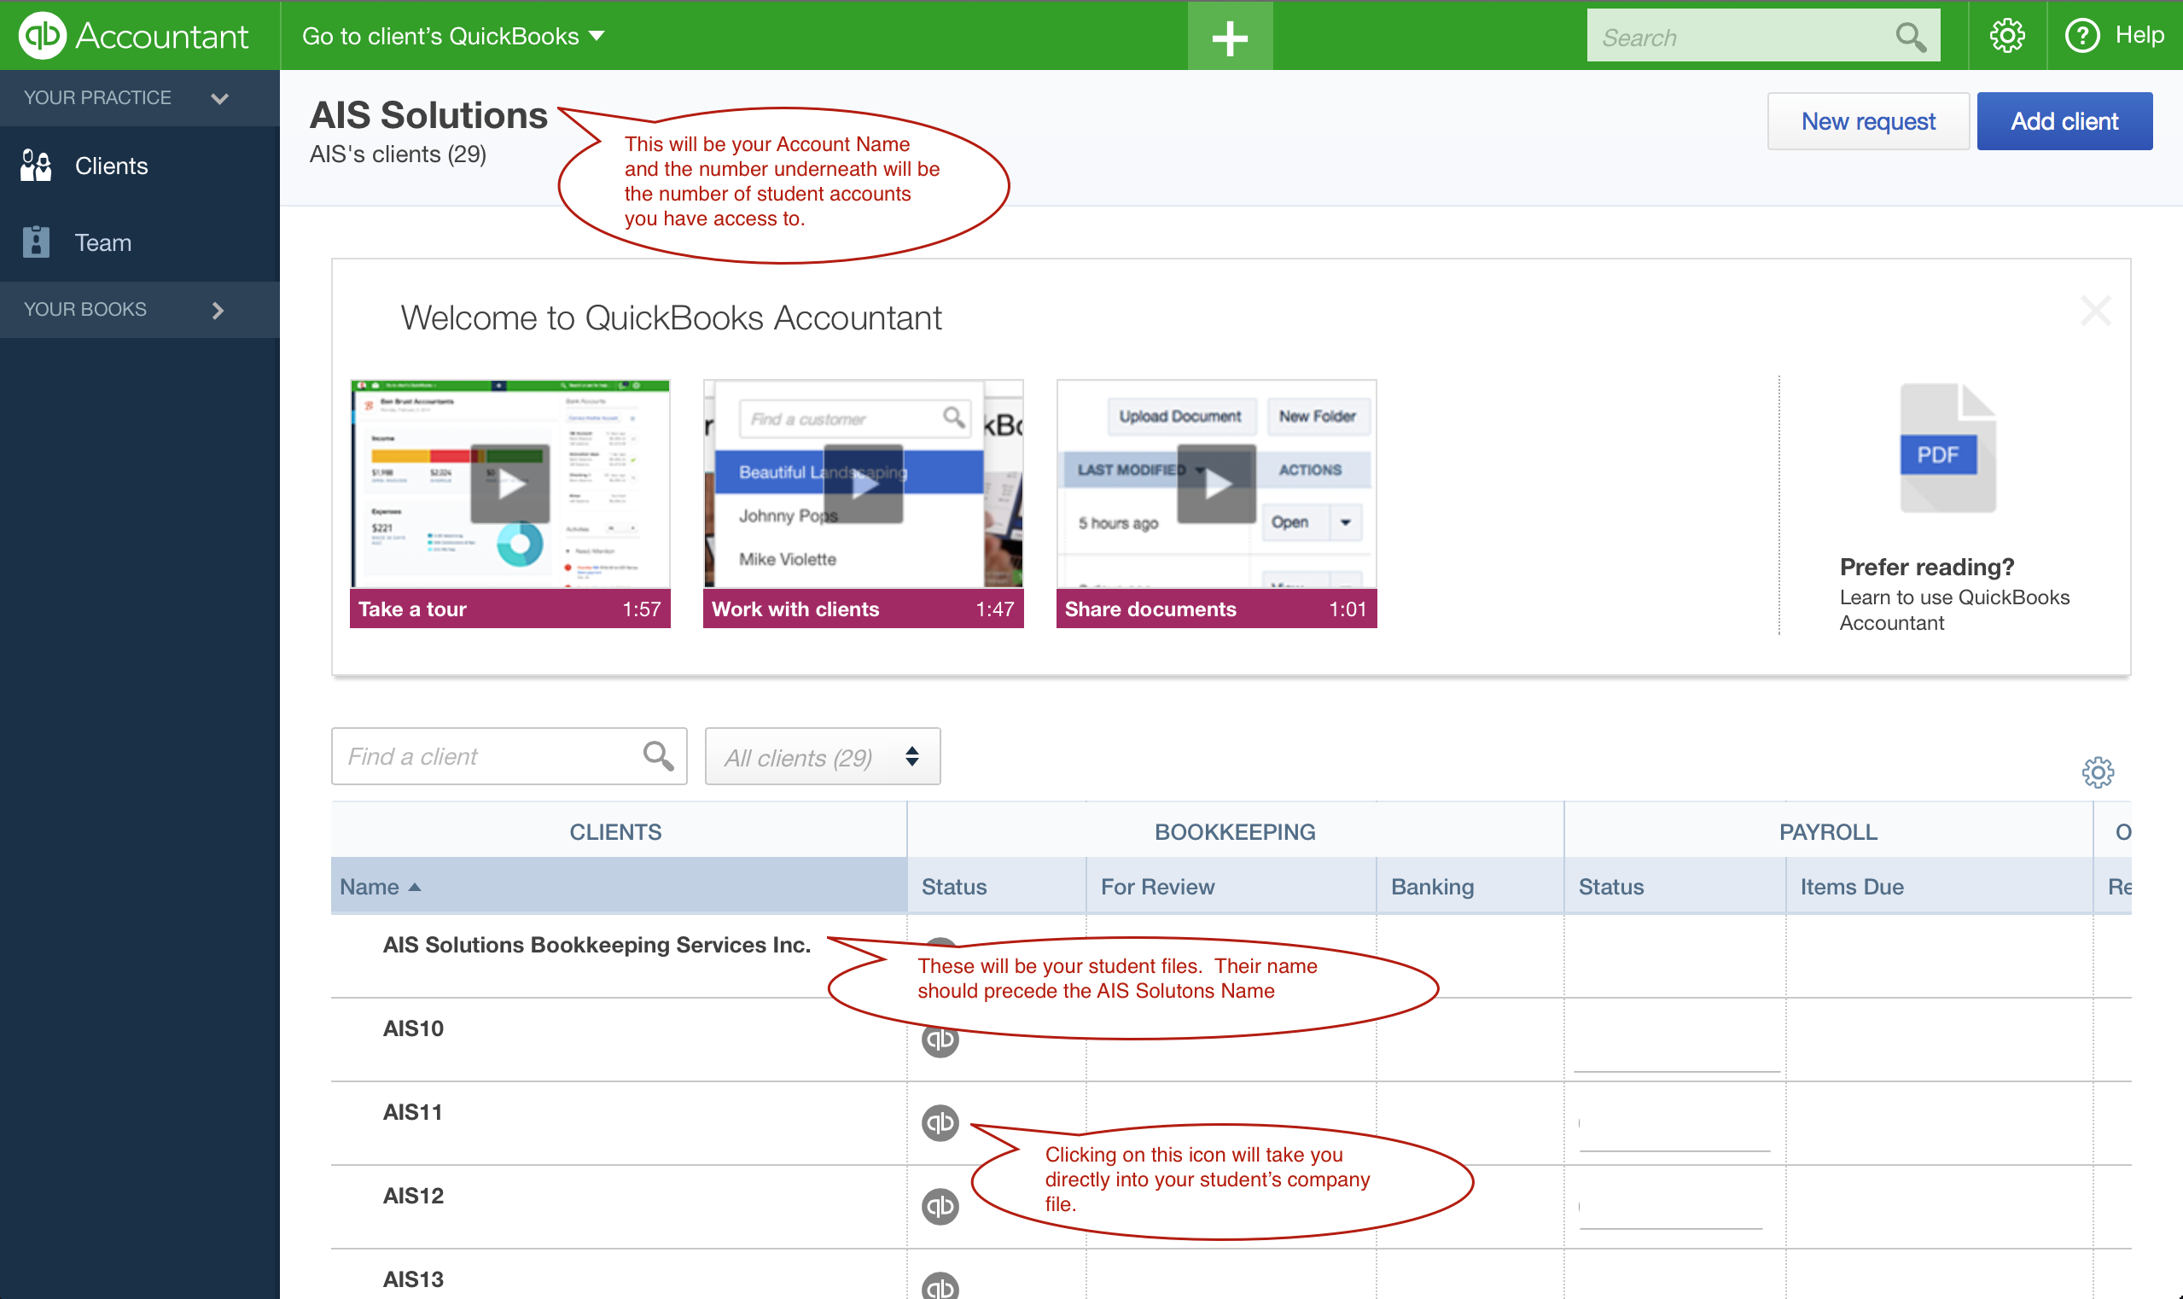

If your client # is too low, then either all of your students haven’t invited you into their databases, or you haven’t accepted all of their invitations.

After you have entered their company file, go to the Gear icon in the upper right hand corner and choose Company Settings

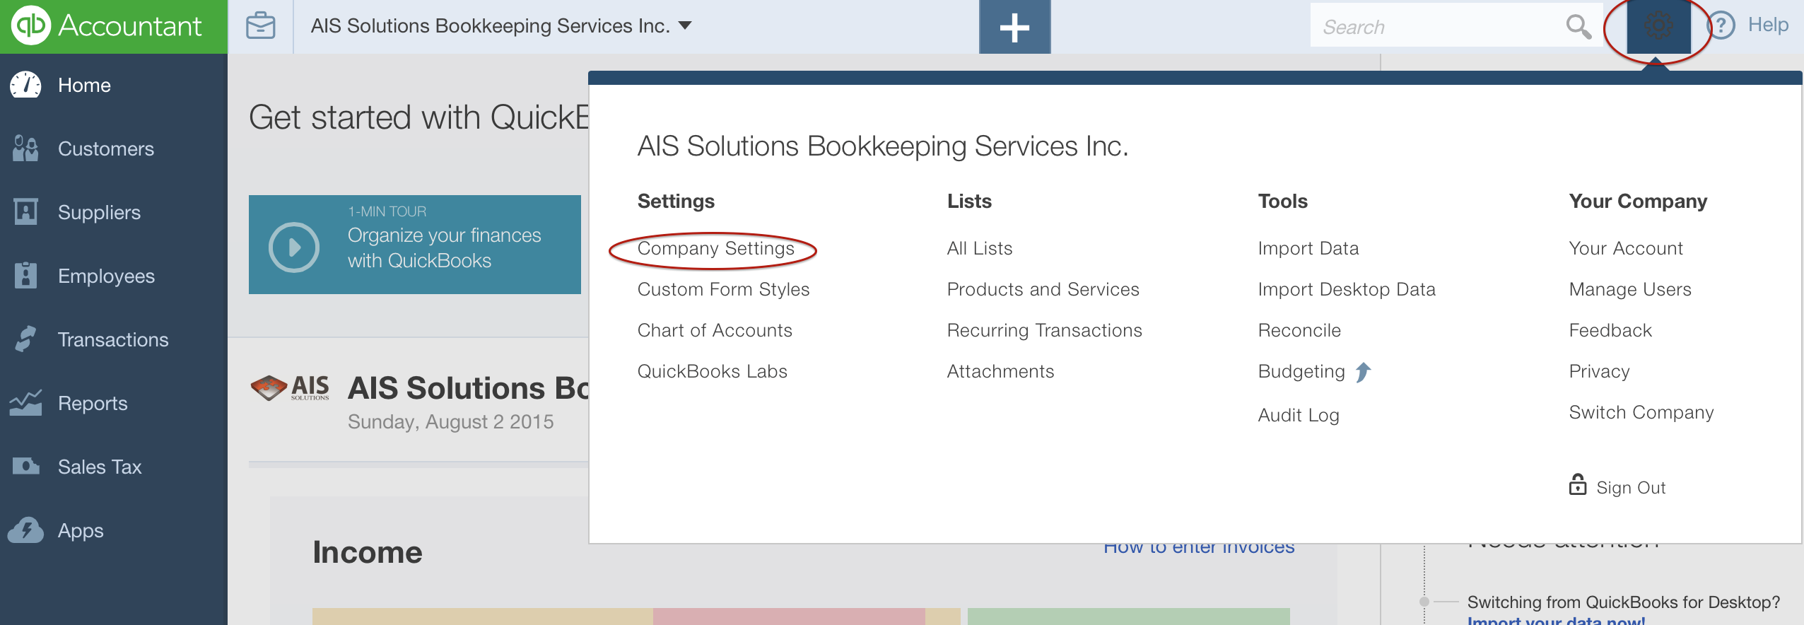

This is what the Settings tab should look like:

Under the Company Tab:

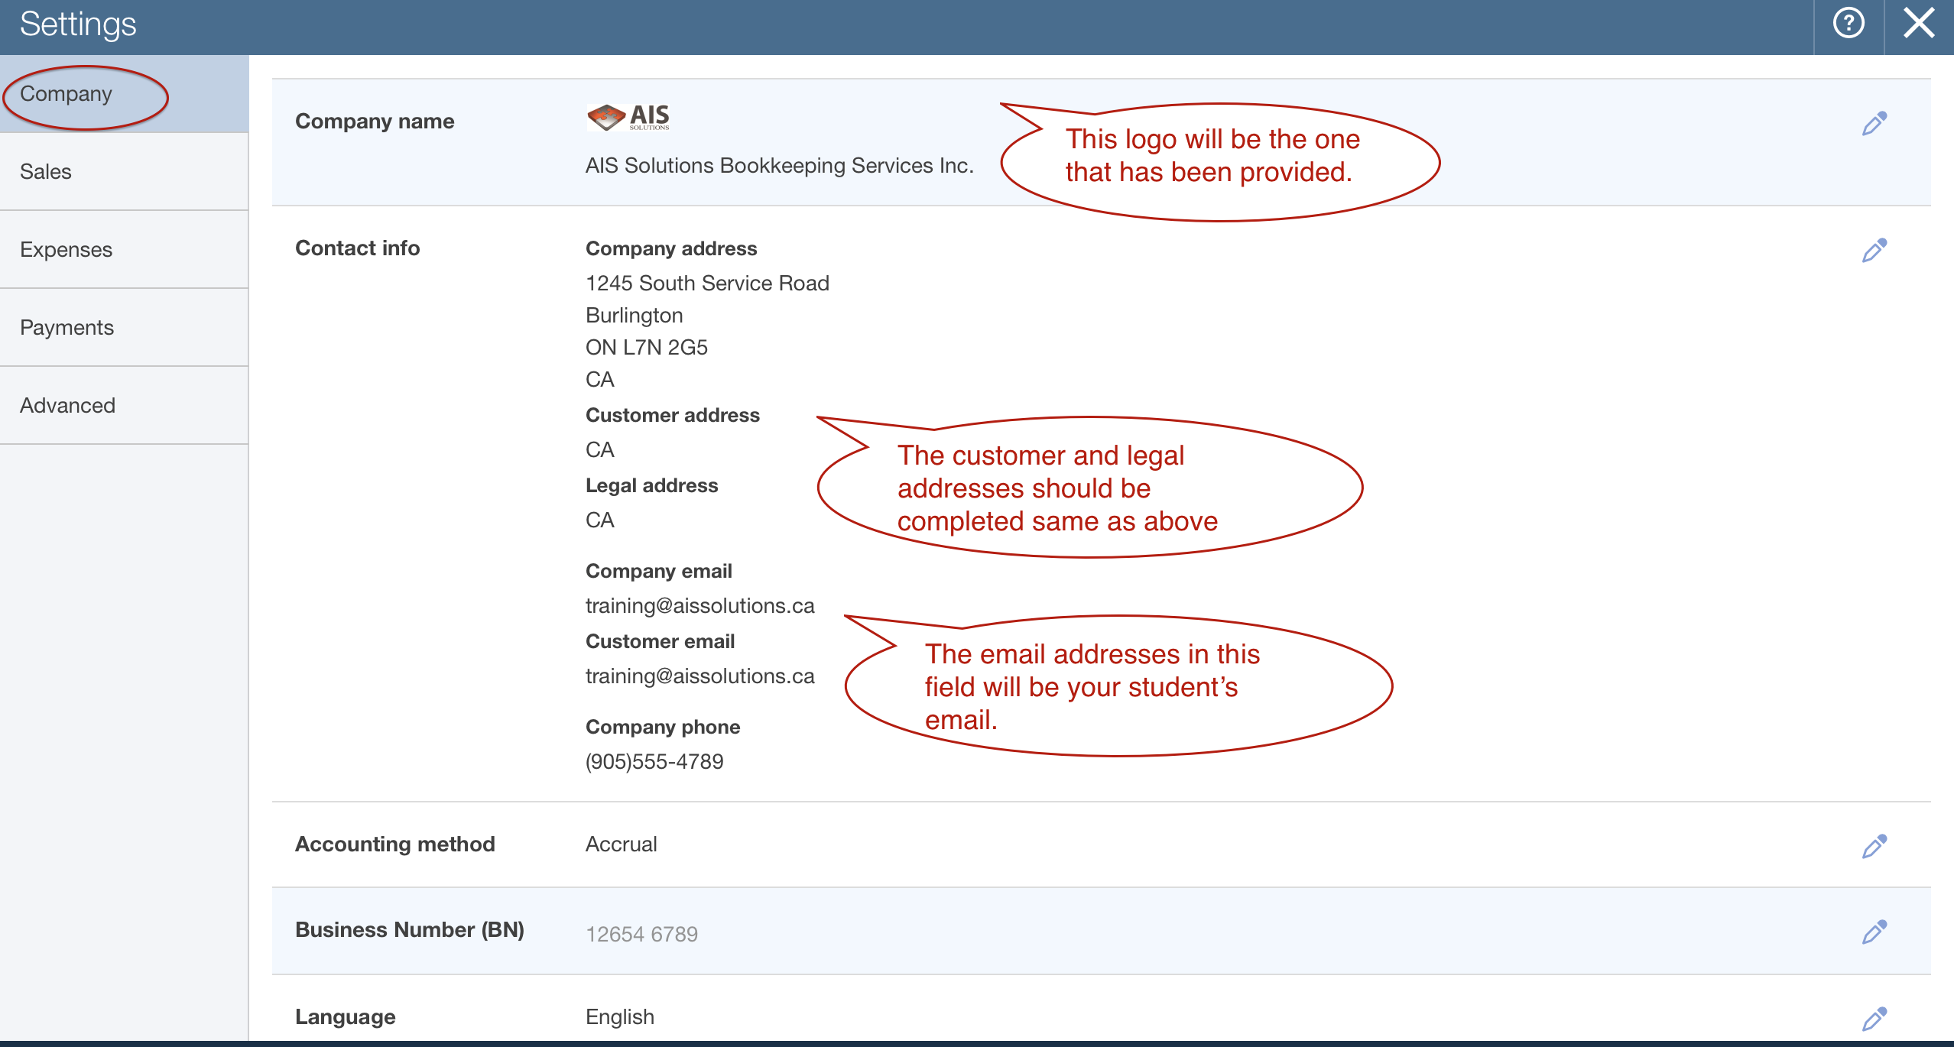

Under the Sales Tab:

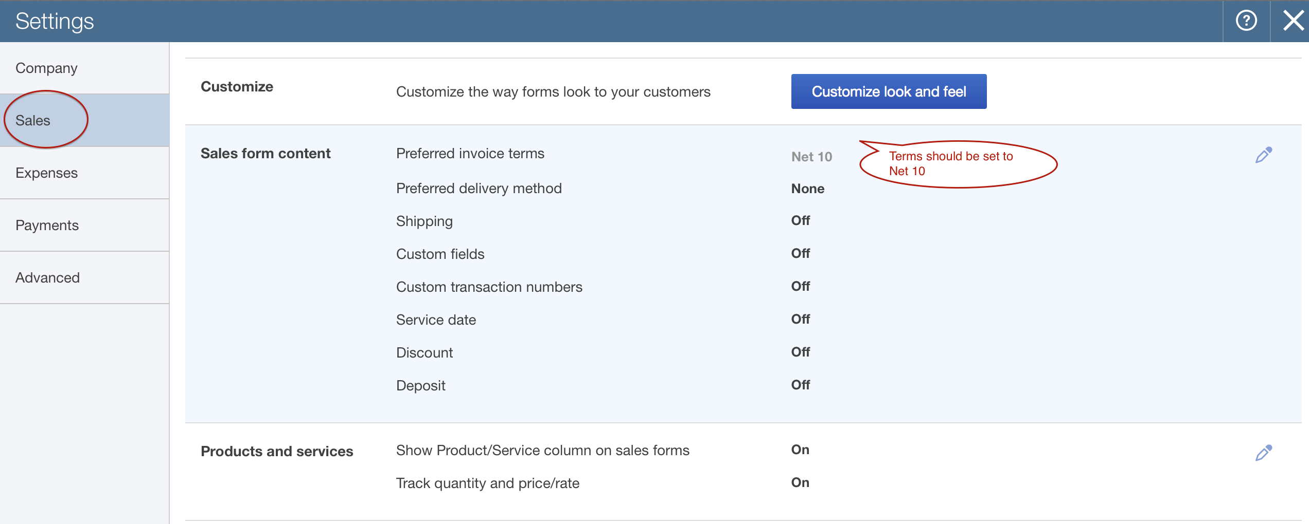

Under the Advanced Tab:

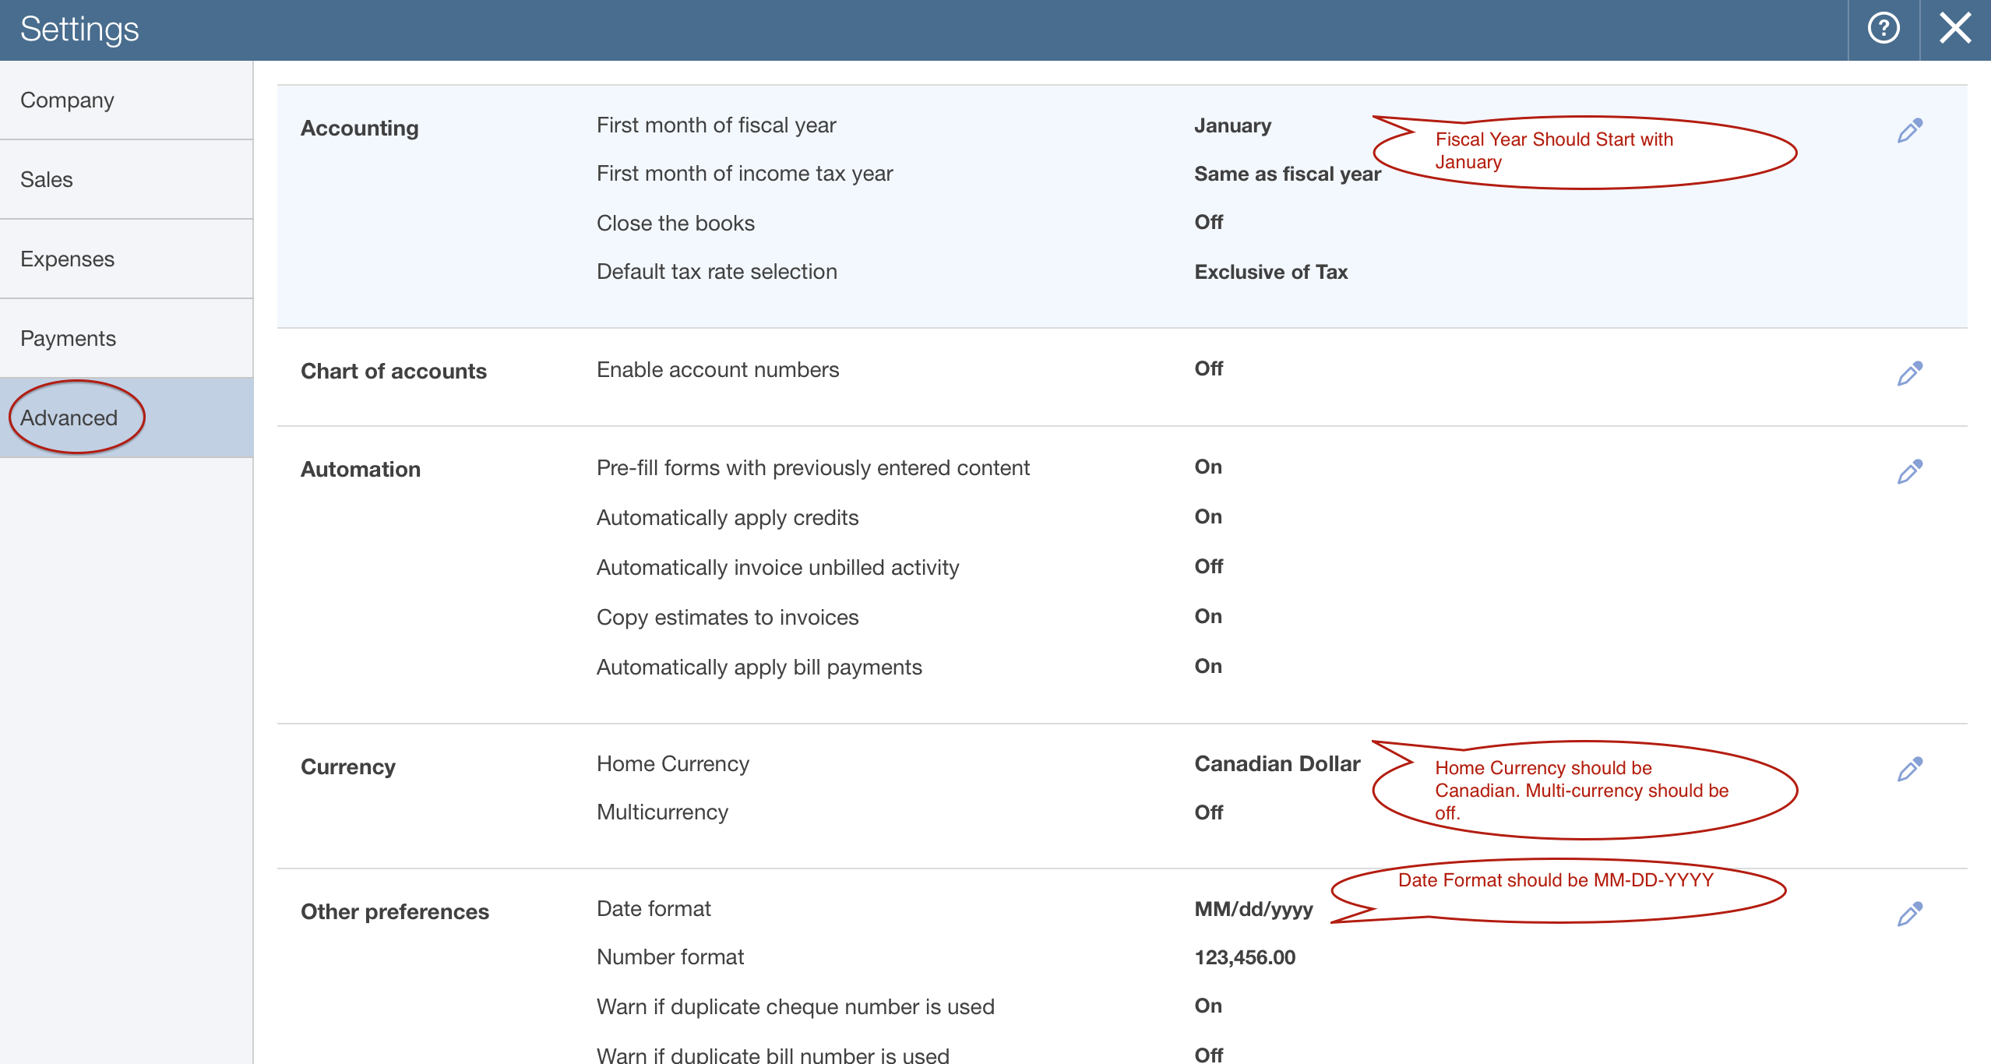

Go back up to the Gear icon and choose Custom Form Styles.
You should see the following:

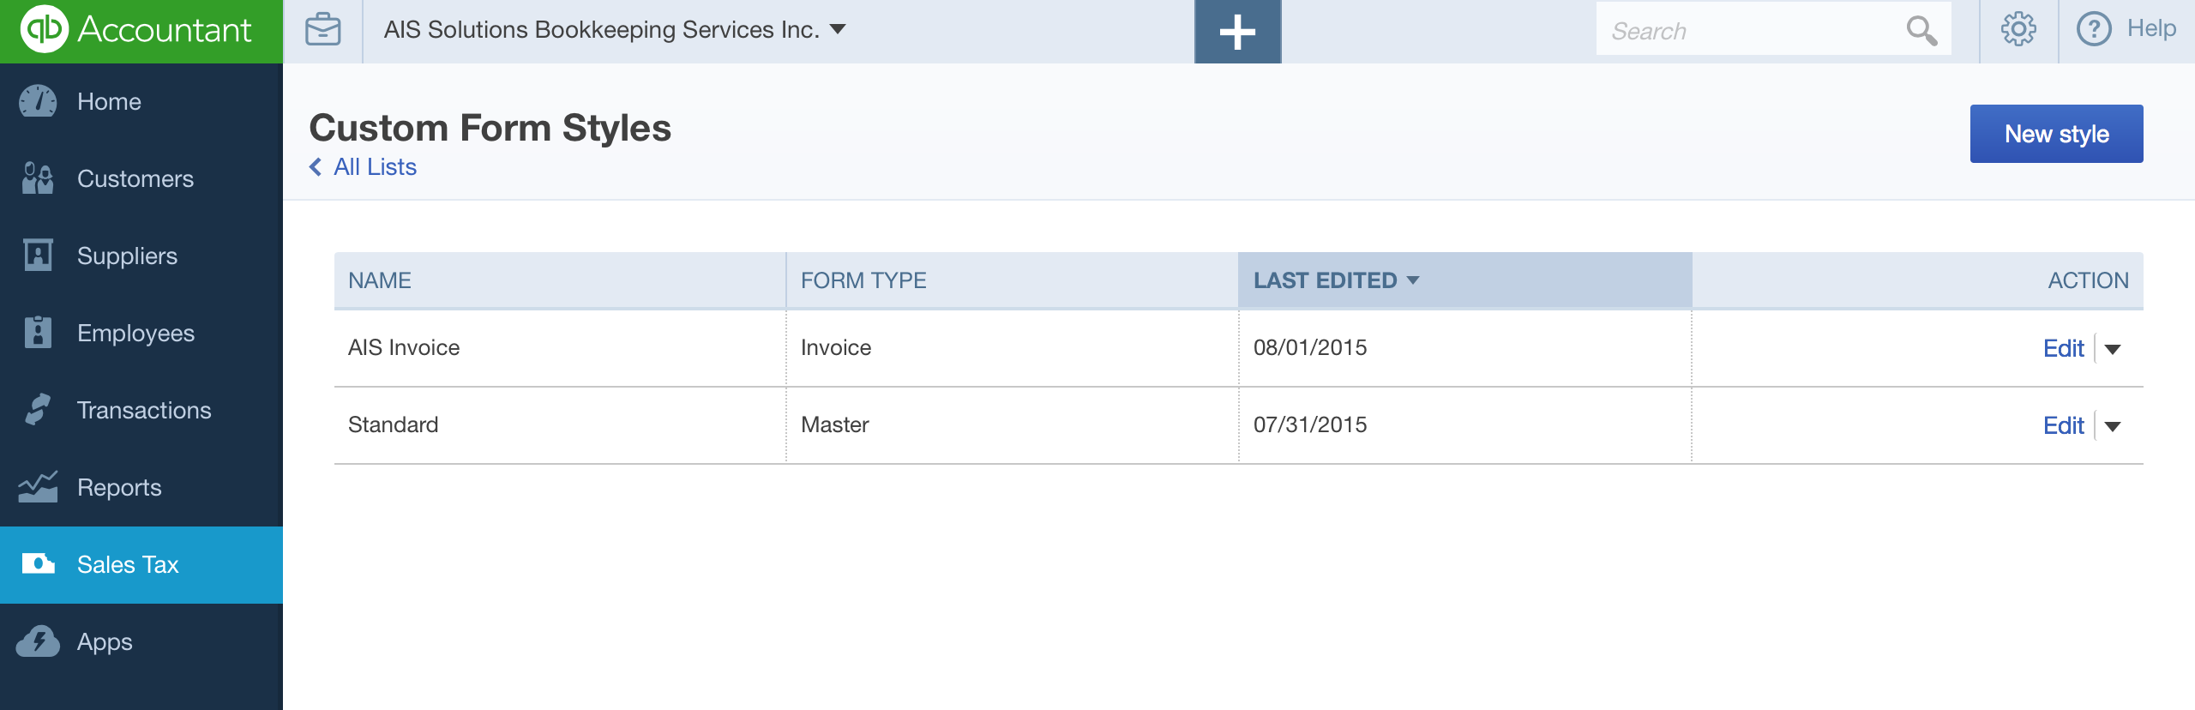

Drop down the Edit Menu and choose Preview. The Invoice Template should resemble the following on the next page.
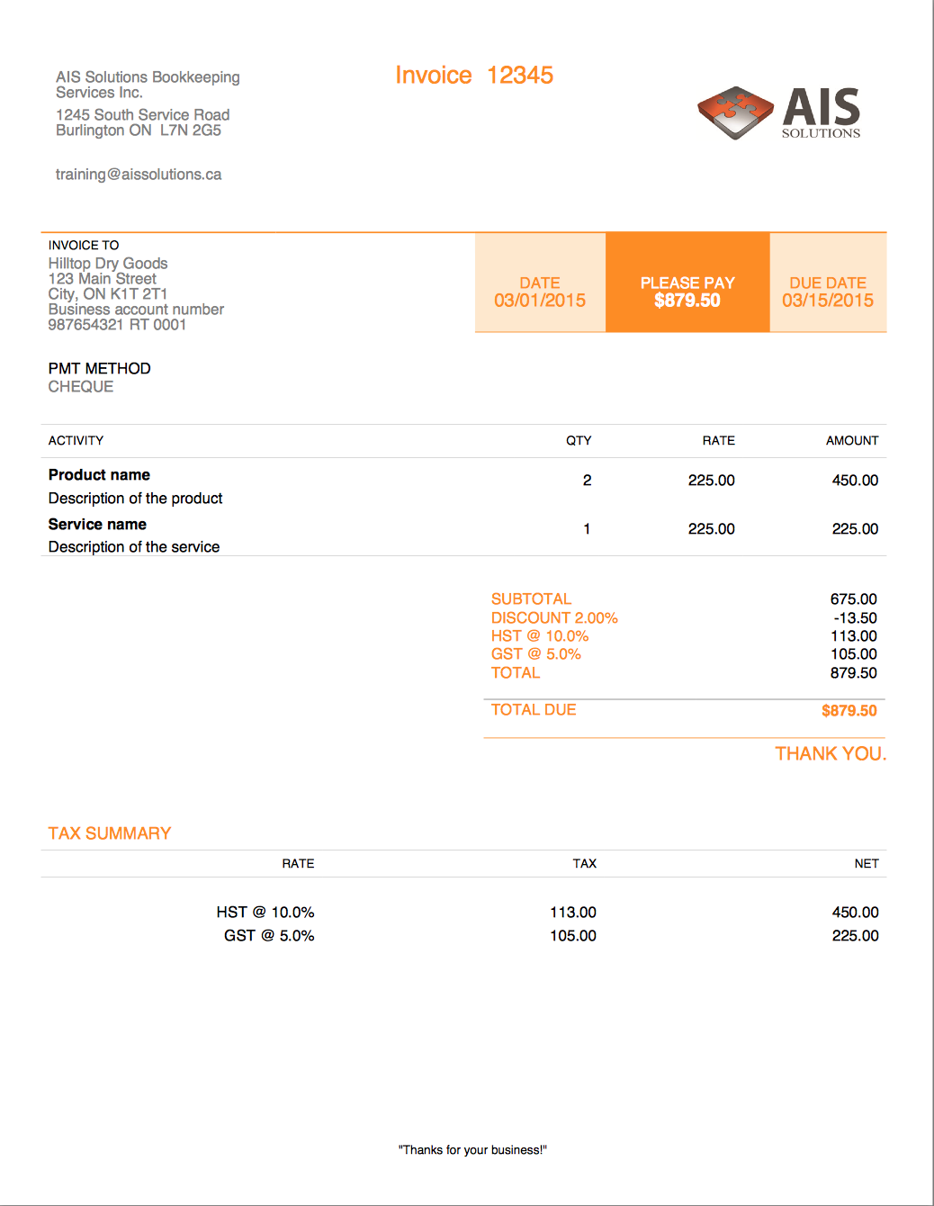

The last thing to check are the Sales Tax Settings. Click on the Sales Tax Menu on the Left Navigation Bar.

Click on Rates and Settings:

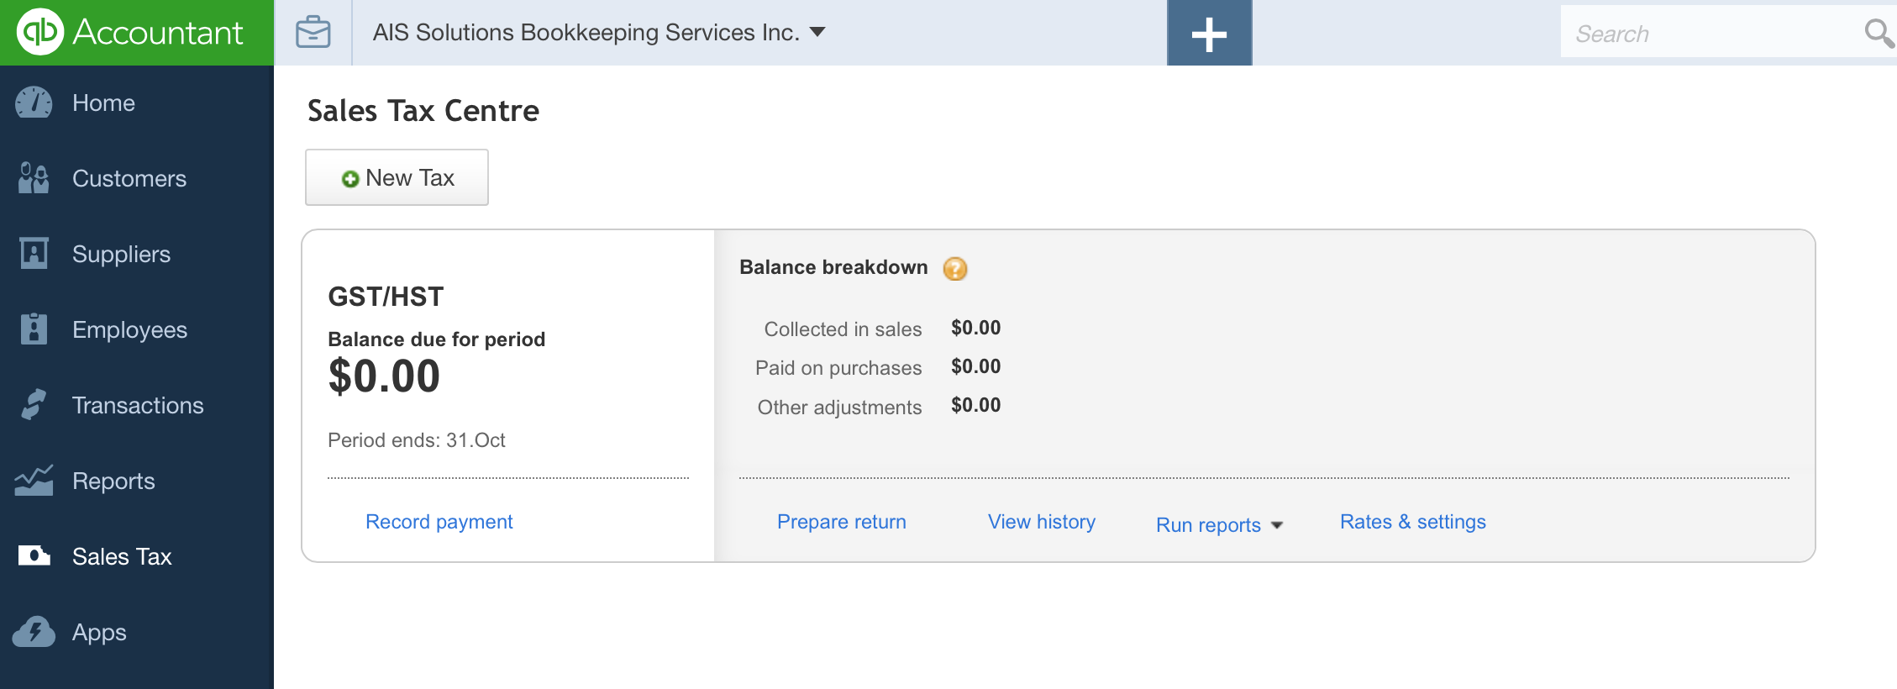

You should see the following setup under Settings:

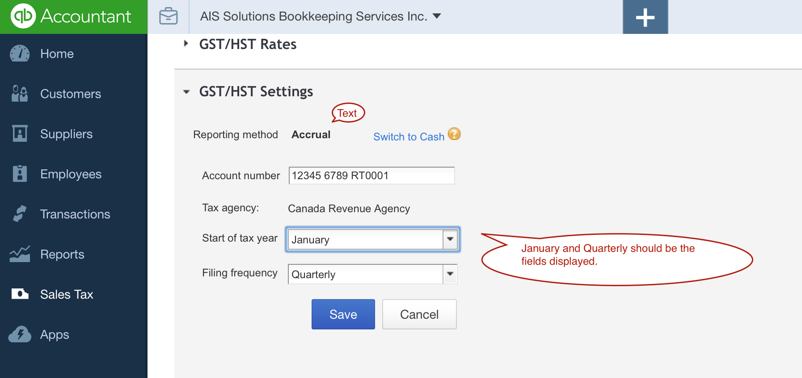

Section 2 Answer Key – Accounts Receivable

Questions 14 – 21
Go to the Gear Icon and choose Products and Services under the List Menu.

Your screen should look like this:

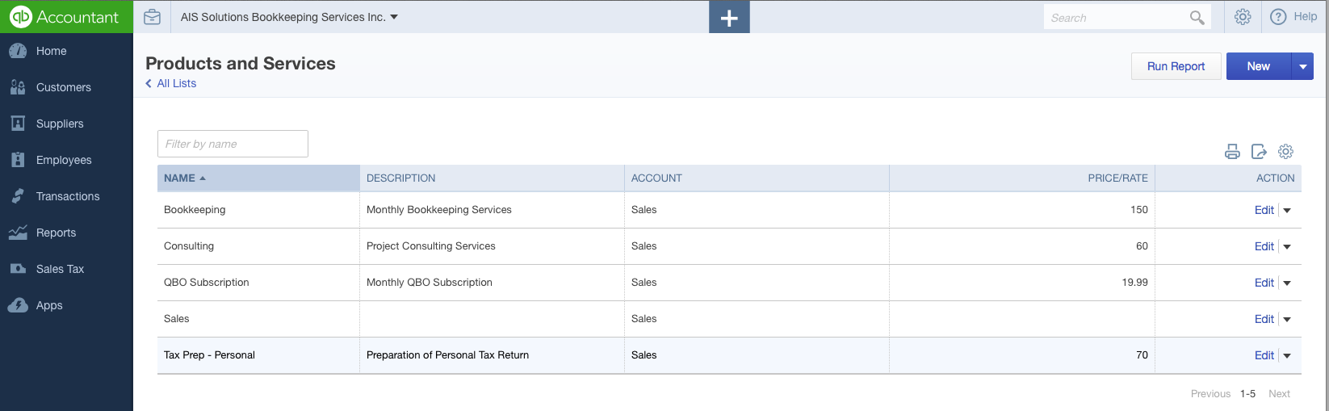

The default Service item called Sales – which QBO sets up automatically will still also be there, as we’ve not asked your students to remove.

The items should have the appropriate prices/rates associated with them.
The Sales Tax and Account Mapping Settings will be evident if they are set up correctly when we run the following reports. Alternatively, you can open up each item and check the settings for each one.

To check that the customers are set up correctly, near the top right corner, in the Search box, type in Customer Contact List. This will then take you to a report listing all of the Customers and Billing information that has been set up for them.

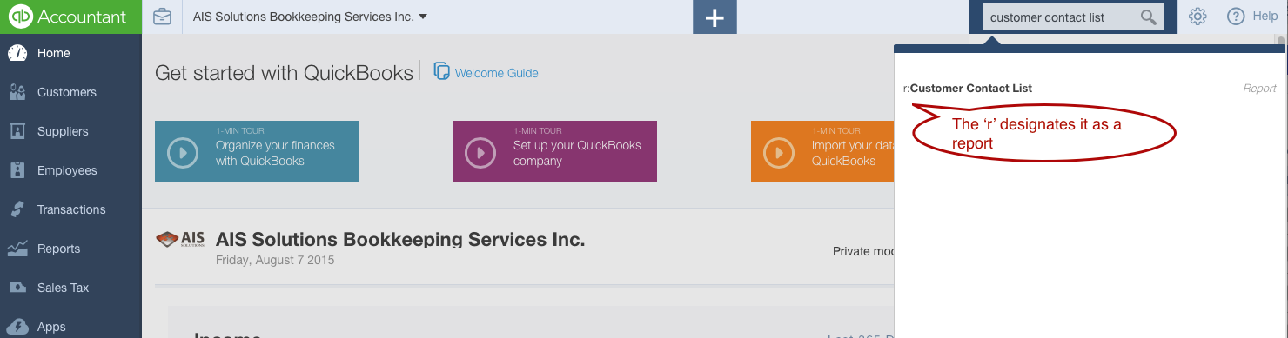

And your report should look like this:

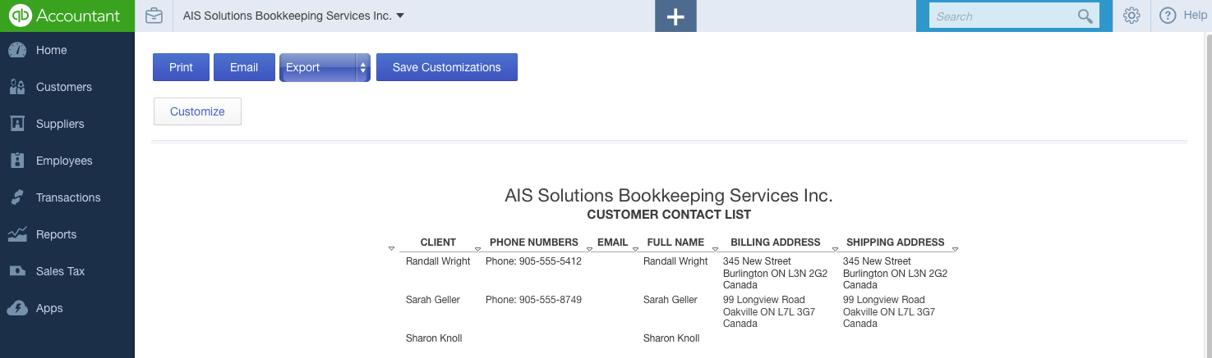

If you had your students do a Customer List Import via Excel in the last section, this report will also have those customers in the list.

To Check the Customer Invoices have been entered correctly, go back to the Search box and type in AR. You will see three options come up AR Aging Summary, AR Aging Detail and Accounts Receivable. You can look at either the Summary or Detail report to review. Note:You will need to change the date of the report to November 22 in order to view the invoices prior to payments being received.

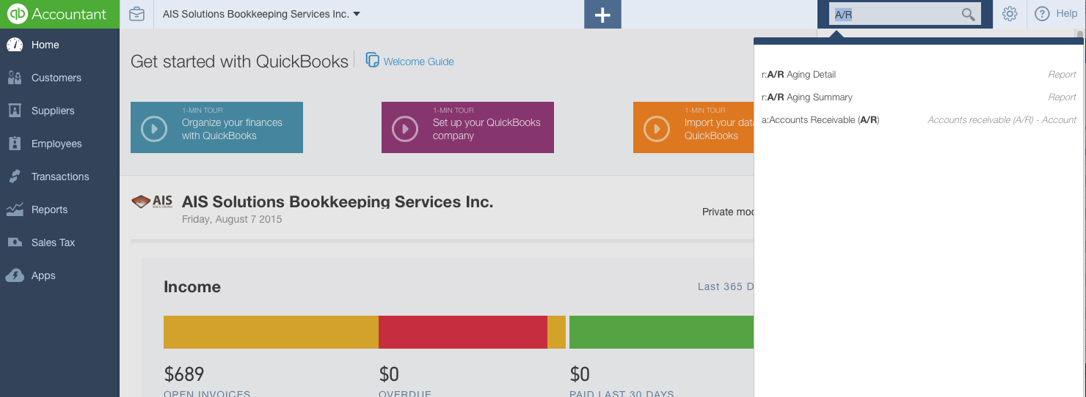

Please note that the amounts are based upon AIS Solutions Bookkeeping Services Inc. being based in Ontario with 13% HST. If you have changed the instructions for your class and asked them to set the company local to your province, your totals may differ in this section and the sections following.

Below is the Summary Report

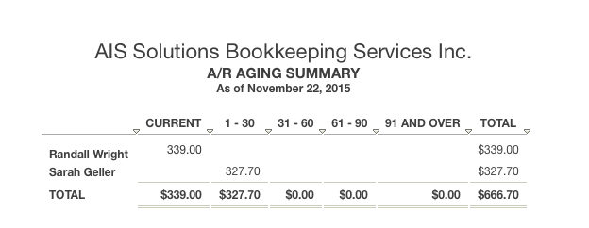

The Detail Report will show you the individual invoices entered, if you would prefer to check those.

You will be able to check both of the Delayed Charge and Conversion to Invoice steps in a single screen. Go to the Customers Menu on the Left Navigation Bar, click on Sharon Knoll’s name and you will see the following list:

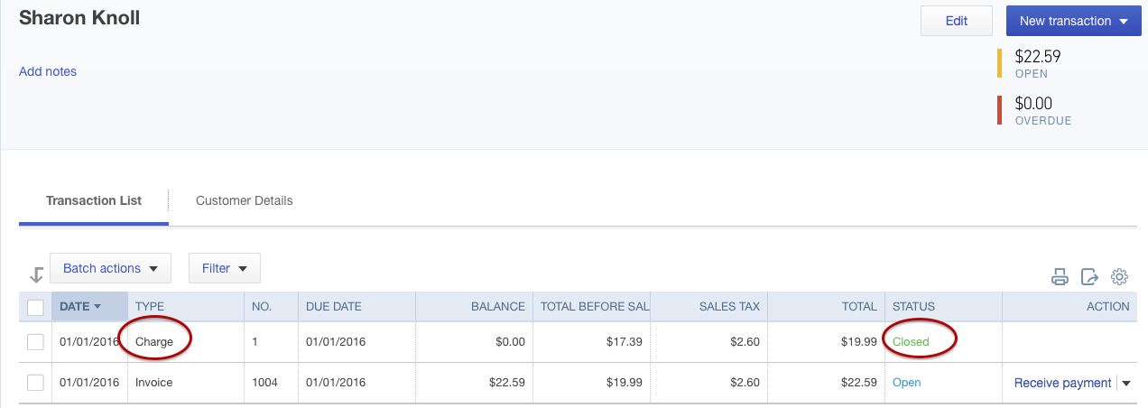

The Charge in the Type Column tells you that a Delayed Charge was used,. And the Status of Closed, tells you that it was then used to create the invoice. The Charge amount will also be pre-tax and the Invoice after Tax.

Receiving Customer Payments

To ensure that the payments have been recorded correctly, run a Register for the Undeposited Funds Account.

In the Search Bar, start typing in Undeposited Funds. Click on the a:Undeposited Funds option that appears in the search results

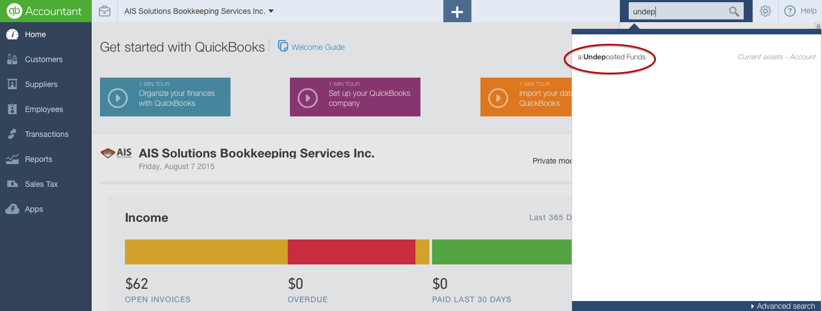

If the payments have all been deposited correctly, you should end up with a 0.00 balance in this account. You can also confirm the dates, and cheque reference number was added correctly.

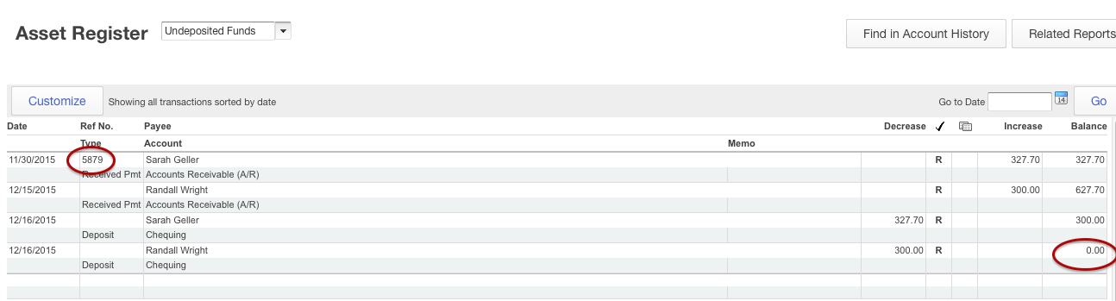

As a final check to this section, confirm that Sharon Knoll and Randall Wright still have balances that are owing.

Click on the Home button from the Left Navigation. The Open Invoices bar should read $62.

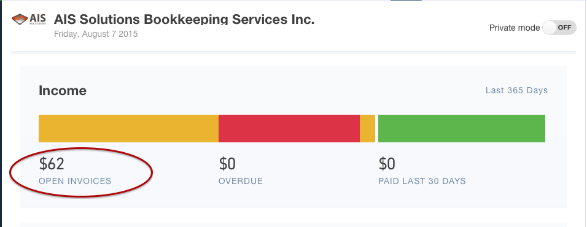

Clicking on the Open Invoices should show you the following open balances.

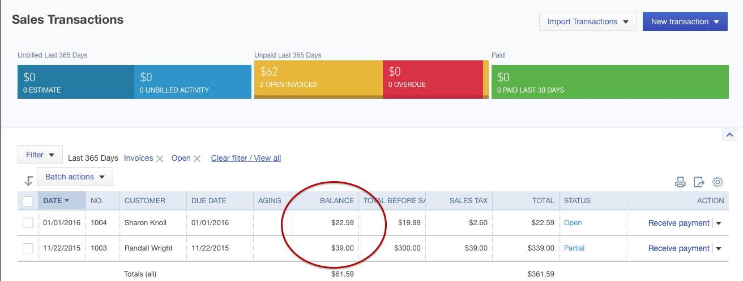

Section 3 Answer Key – Accounts Payable

Questions 22 - 26

Similar to the Customer Contact List, we are going to run a Supplier Contact List to confirm the vendors have been set up correctly.

In the Search Bar, type in Supplier Contact List and you should see the following:

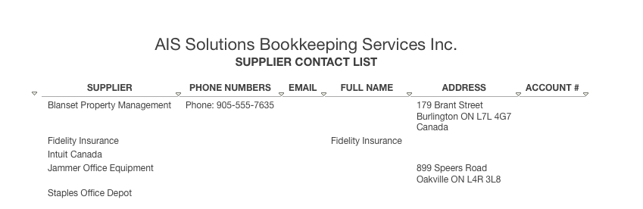

Again, if you had your students import Vendors from an Excel sheet, this report will also reflect those supplier names.

As the bills that have been entered have been paid already in this section, to confirm the entries you won’t be able to run AP Aging Reports. So the easiest way to check all of these entries is by confirming balances on the Home Screen Dashboard and then drilling down to the individual transactions.

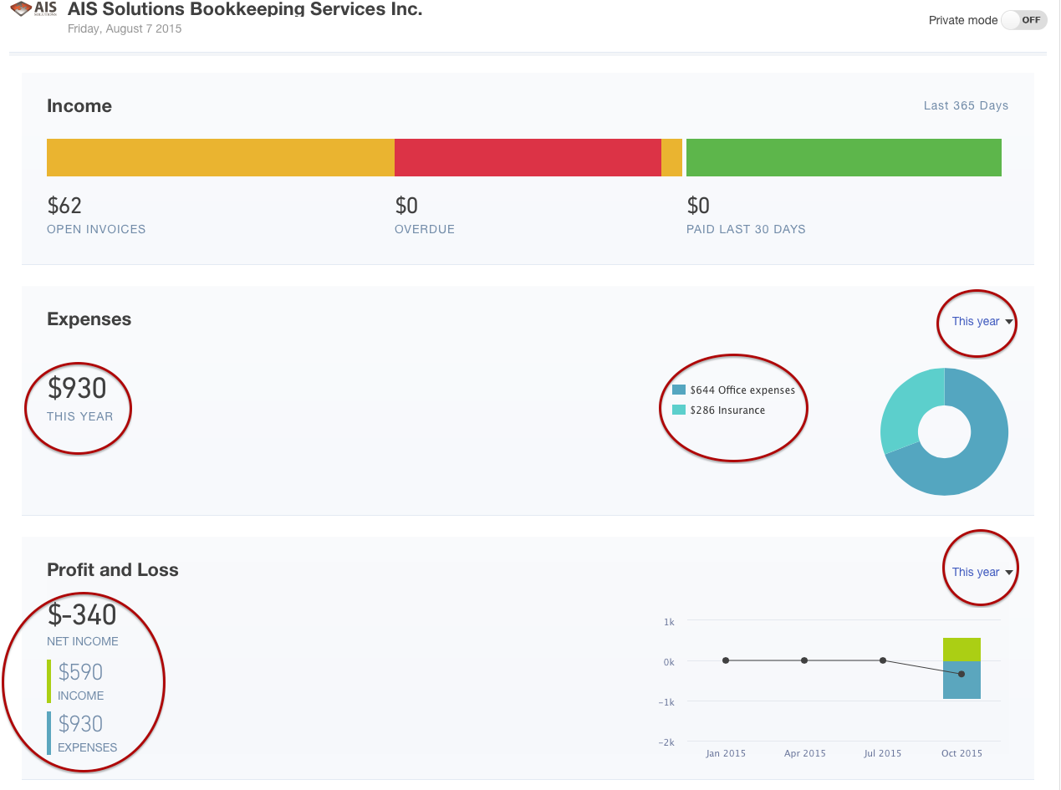

You want to ensure that you change the dropdown in the top right corners to “This Year” if you are in the Fall term, or “Last Year” if you are in the Spring Term. This will then pull up the total for all of the transactions. You are confirming the following information in the Expenses section:
- Total Expenses - $930
- Office Expenses - $644
- Insurance - $286

And in the Profit and Loss section
- Net Income - $(340)
- Income - $590
- Expenses - $930

All of the numbers listed above will again be based upon AIS Solutions Bookkeeping Services Inc. being set up as an Ontario business with 13% HST. If you changed those initial parameters for your students and you are in another HST only province, you will see the same numbers. If you are in a province with PST, then the numbers above should also include the PST portion of the expenses.

You want to check that the Sales Tax expenses are being captured correctly, so do run a Sales Tax Report to confirm.

Go into the Sales Tax Centre from the Sales Tax Menu in the Left Navigation Bar. From the Run Reports Option, Choose Detail

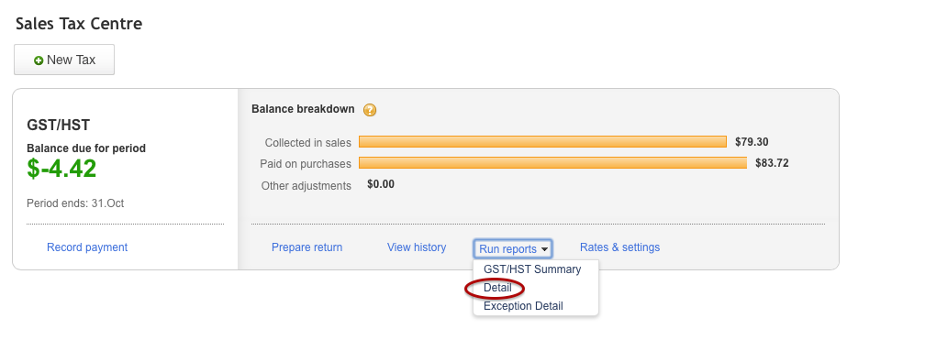

Here is what your report should look like – again date range should be “This Year” if you are in the Fall Term, and “Last Year” if you are in the Spring Term.
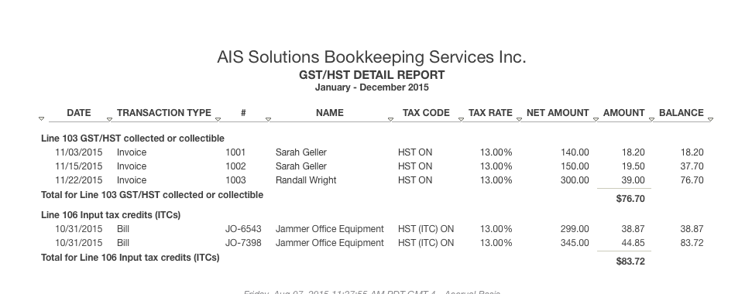

Section 4 Answer Key – Automating in QBO

Questions 27 – 28

Both the Recurring Invoices and Supplier Bills can be confirmed by running a single report.

From the top Gear icon in the right hand corner, choose Recurring Transactions under the List Menu

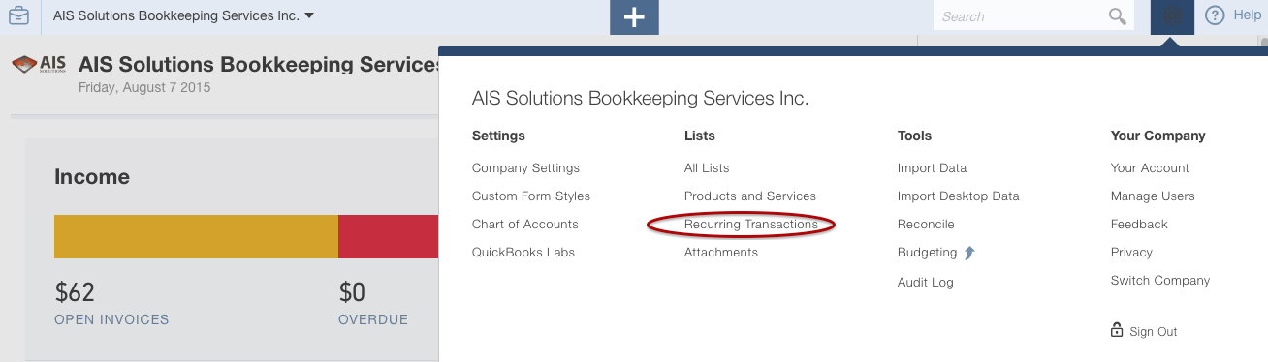

The Recurring Transaction List should appear as follows:

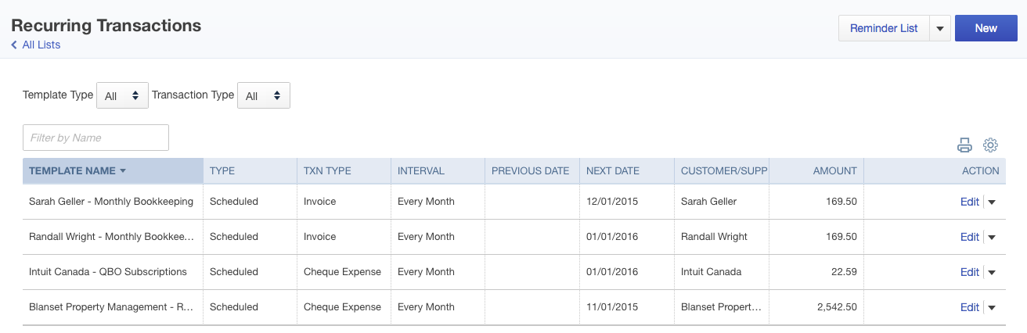

Section 5 Answer Key – Company Administration

Question 29

From the Gear icon in the top right hand corner, choose Manage Users

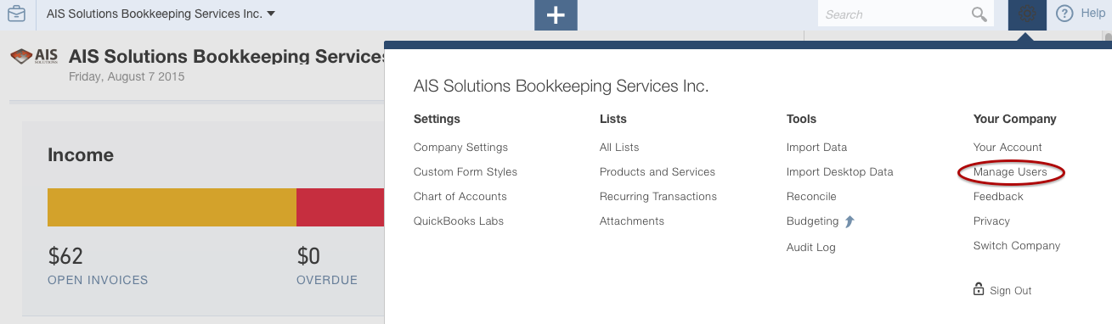

Your screen should now look like this. Instead of student@aissolutions.ca you should see the email address of the student, or any other alternate email address they may have used. If they have gone through the step of accepting the invitation, instead of the “Pending “notification, it may show as “Yes”

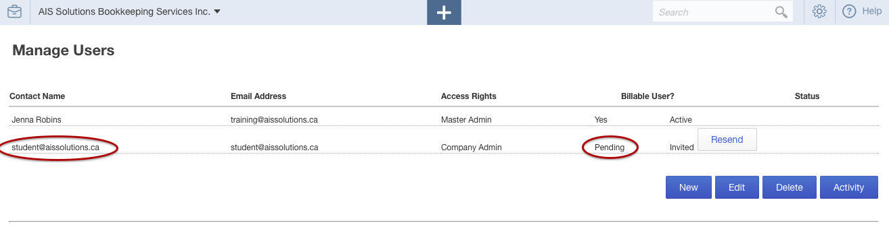

Section 6 Answer Key – Advanced Learning

Questions 30 - 32
From the Plus icon choose Journal Entry

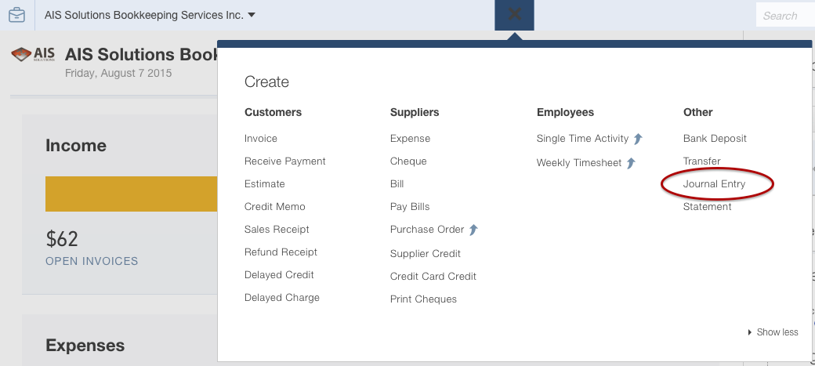

In the top right corner, choose Recent Transactions, by clicking on the clock icon.

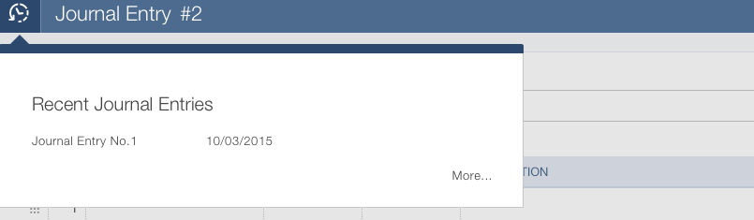

You should see the Journal Entry #1 entered by your student. Click on the entry to open up and display the transaction. Depending upon whether you had them import a chart of account list from excel at the beginning of this workbook, they may have chosen a different account for one side of the transaction. We’ve chosen Opening Balance Equity, which is a default account in QBO, if you didn’t have any extra accounts set up.

The main things to watch for are whether they are able to post the journal entry and that the entry going into the Chequing account is a debit.

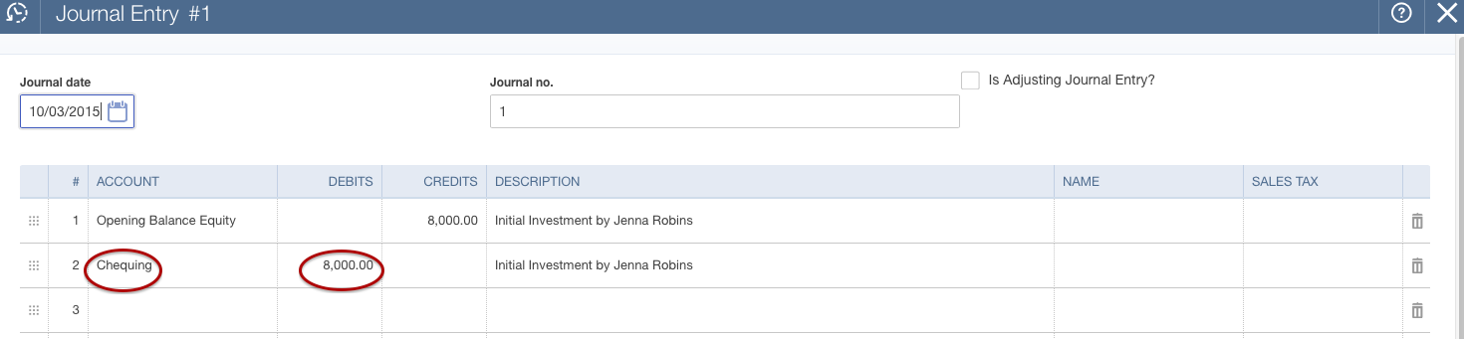

Bank Reconciliation

From the Gear Icon choose Reconcile under the Tools Menu.

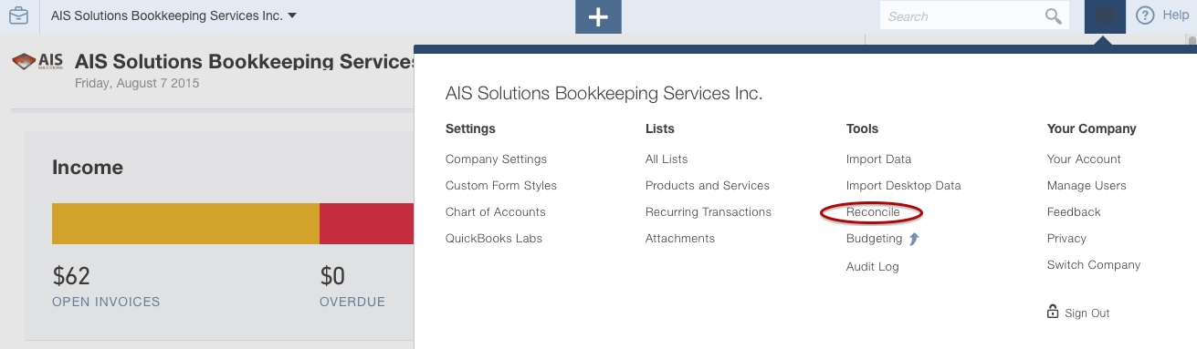

You should see the first reconciliation completed on the next page, and the date that the reconciliation is completed. To see the detailed reconciliation, just click on any of the fields in the row.

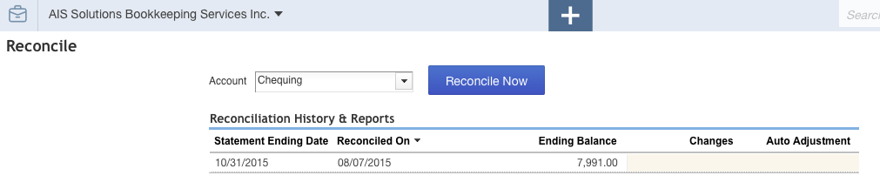

The Reconciliation Report would look as follows on the next page:

<INSERT PDF File – Reconcile Session Report – Provided>

Filing Sales Taxes

QBO does not provide your students with the ability to file an HST return at a future date. So, for example, if you are teaching this in the fall term, your students would not be able to file the HST return until January, which is likely when the term is over. For that reason, the workbook asks them to print the return and provide it to you. Please advise them whether you want it to be emailed to you, or a hard copy provided in class.
If they have chosen the date range correctly in QBO, the information on the return should be as follows:
- Line 101 - $590
- Line 105 - $76.70
- Line 108 $83.72
- Line 113C - Refund owing is $7.02

Section 7 Answer Key – Reporting

Questions 33 - 37

To ensure that the reports have been saved by your students go the Reports Menu in the Left Navigation Bar. Click on My Custom Reports and you should see the following:

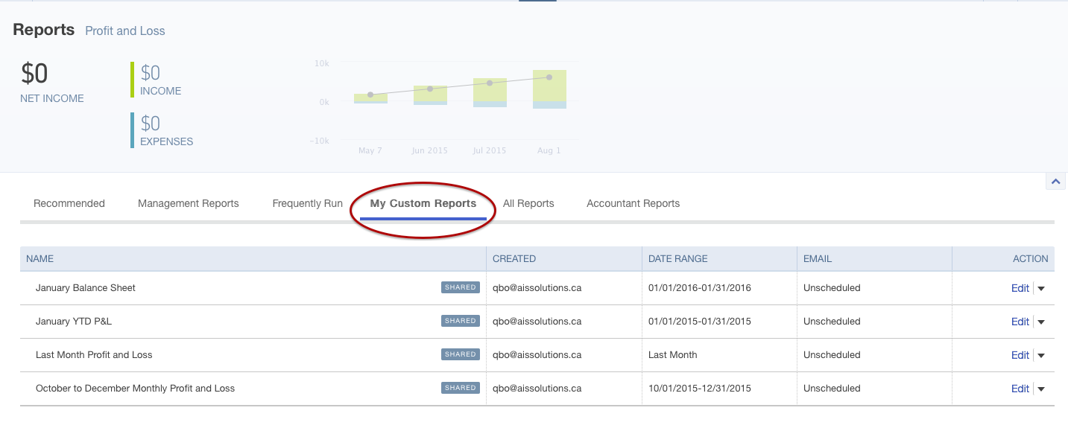

You will have to run the reports in order to view their submission. Click on the Edit dropdown, and Run Report

The report should appear similar to the reports on the next pages.

<INSERT PDF Balance Sheet Jan 31.pdf>

<INSERT PDF Profit and Loss January Only.pdf>

<INSERT PDF October to December Monthly.pdf>

To ensure that your students have automated the monthly income statement for distribution, you will notice that the fields Date Range and Email will be different in the My Custom Reports List.

